Qlik Cloud  Mobile mashup for OAuth access  - Console Setup Instructions | 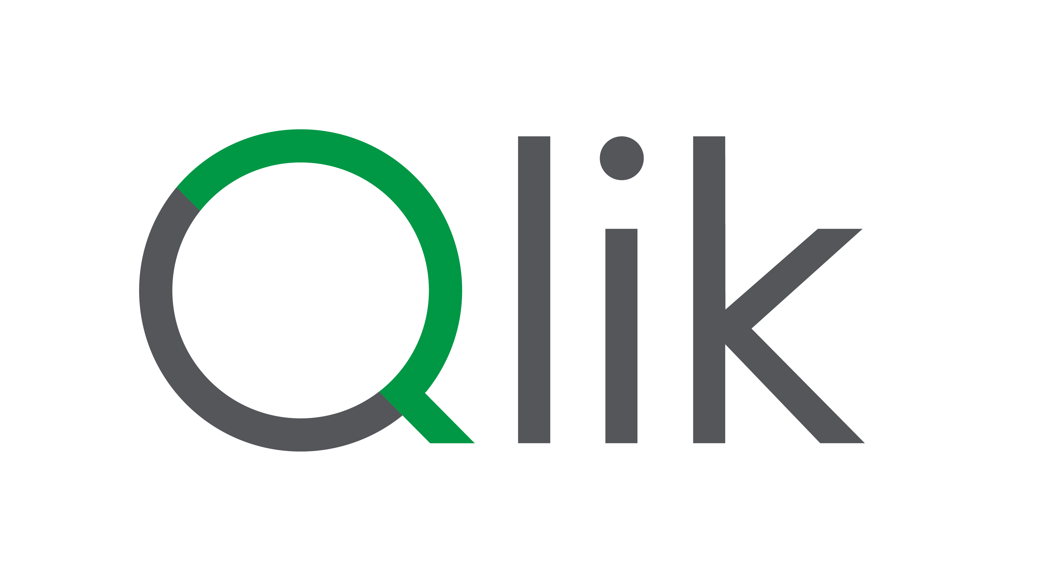
Using anonymous access is an excellent option when you want to easily share your content with general access.
We will focus this use case specifically on mashups and the Qlik Embed API..

Reuse your current tenant
You don’t need any specific tenant rather than the one you already own or some of the shared ones you belongs to.
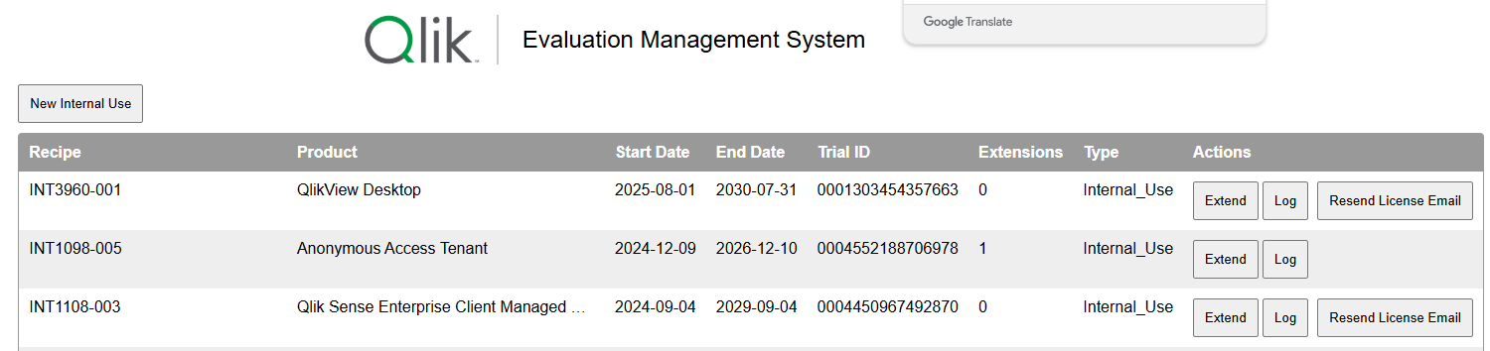
Provide access to the app
As you probably already know, the most important raw material for a mashup is still a Qlik Sense application.
It's Qlik's QIX engine that's responsible for responding effectively, just as we would with a browser and a desktop.
With a mashup, we simply offer access to that same app through a different environment.

In this case, OAuth access, the access to the app in the mashup will be controlled the same way we provide access for Desktop use.
The app can stay in any type of space Shared or Manged (keep in mind, in a Personal space only you will have access).
2 options:
- You can provide access adding members to the space
  - ‘Has restricted view’ is the minimum rights to access needed
- You still can share the app with other rather than only space members

(more about basic spaces management here)

Set up an OAuth ClientID
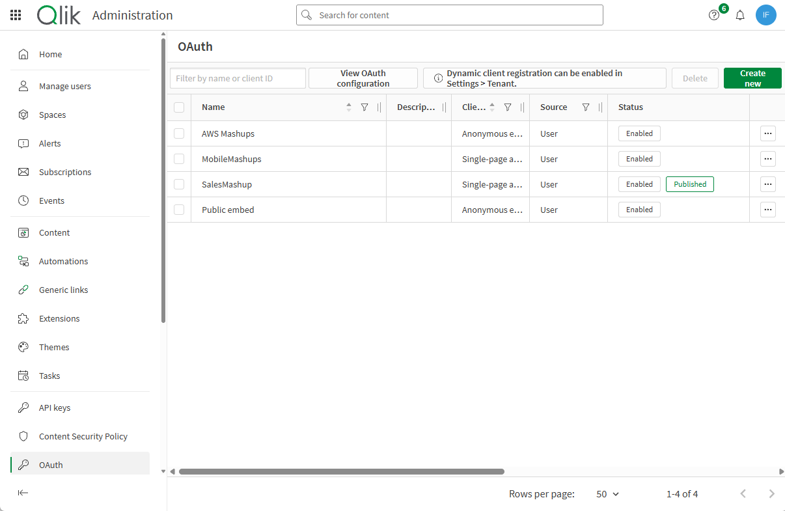
A clientId is needed to enable access through a mashup, no matter if it’s an anonymous or authenticated access.
In this case will set up an authenticated ClientId.
Try it: go to the administration console, search for the oauth option:
- Click on ‘Create New’, button on the top right.
- First option ‘Client Type’ = Single-page application.
- Type a ‘Name’
- ‘Description’ is optional, but very recommended, as you will probably end-up with several clientids.
- ‘Scope’ User default
- ‘Add redirect URLs’ , use the repository you chose to keep your mashup and join the ‘oauth-callback.html’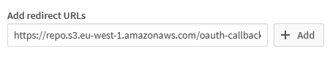
Example for S3 bucket:
https://repo.s3.eu-west-1.amazonaws.com/oauth-callback.html
Example for Github repository:
https://repoqlik.github.io/proyectQlik/oauth-callback.html
This oauth-callback.html is generated by the mashup builder, but here are some info about how to generate it manually.
- Add an ‘Allowed origin’, that’s the URL of the repository you use to allocate your mashup.
Ex. If your mashup is in a S3 bucket
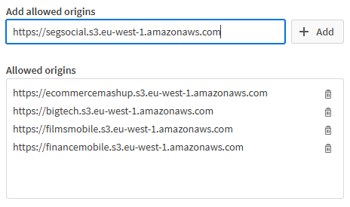
Ex. If your mashup is in a GitHub repository
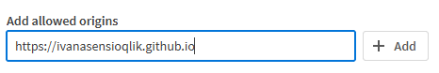
Keep in mind: you can only use a maximum of 5 repositories for each ClientId
- Click ‘Save’ and copy the ClientId

Have doubts about how to get that allowed origin URL?
Please follow the instructions in the document:
- Set up S3 bucket for Qlik Cloud mashups.docx
- or Set up Github pages for Qlik Cloud mashups.docx

